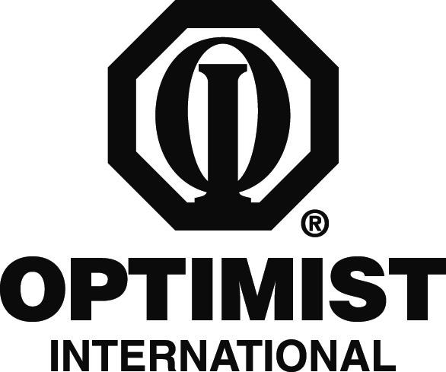

PRINT ON DISTRICT LETTERHEAD OR TYPE IN DISTRICT NAME

CONTACT
DISTRICT CONTACT
CONTACT'S NUMBER

FOR IMMEDIATE RELEASE
DATE

Local Student Wins Optimist District Essay Contest

CITY, STATE/PROVINCE – STUDENT NAME, a YEAR IN SCHOOL at SCHOOL, recently won the DISTRICT NAME Optimist essay contest based on a theme of “Chasing Optimism in the Face of Challenges.”

STUDENT LAST NAME was awarded a $2,500 scholarship for the honor. In addition, the essay will be sent to the international level to be judged along with winners from other Optimist districts. One international winner will be chosen and will receive an engraved plaque and recognition in The Optimist magazine.

“STUDENT NAME did a wonderful job of articulating this year’s theme. HE/SHE expressed HIMSELF/HERSELF well through the essay and deserved the honor of first place,” District Essay Chair CHAIR'S NAME said.

The DISTRICT NAME has been participating in the Optimist Essay Contest for NUMBER years.

Optimist International is one of the world’s largest service club organizations with 75,000 adult and youth members in 2,600 clubs in the United States, Canada, the Caribbean and Mexico and throughout the world. Carrying the Mission Statement “By providing hope and positive vision, Optimists bring out the best in youth, our communities and ourselves,” Optimists conduct positive service projects that reach more than six million young people each year. To learn more about Optimist International, please call (314) 371-6000 or visit the organization’s website at www.optimist.org.

###

