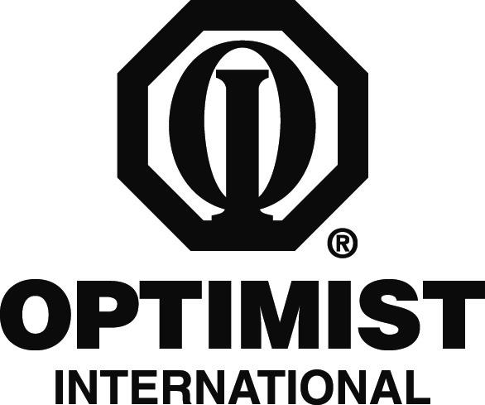

PRINT ON CLUB LETTERHEAD OR TYPE IN CLUB NAME

CONTACT
CLUB CONTACT
CONTACT'S NUMBER

FOR IMMEDIATE RELEASE
DATE

Local Optimist Club to Sponsor SPORTS CONTEST/TEAM

CITY, STATE/PROVINCE – The Optimist Club of CLUB NAME wants to promote fun and good physical fitness for local children through this year’s LIST SPORTS CONTEST OR TEAM.

EXPLAIN PROGRAM IN SEVERAL SENTENCES

“Good fitness is important to the development of a child, both physically and in the area of self-esteem,” Club President PRESIDENT NAME said. “Our Optimist Club wants to encourage children to stay active and do what we can to boost their self-confidence at the same time. And of course we want them to have fun as well!”

Individuals wanting to learn more about the club’s program can contact the club at CLUB CONTACT NUMBER.

The Optimist Club of CLUB NAME has been participating in this program for NUMBER years and has been active in the community since CHARTER YEAR. Other programs and service projects that the Club is involved in include CLUB PROJECTS.

Optimist International is one of the world’s largest service club organizations with 75,000 adult and youth members in 2,600 clubs in the United States, Canada, the Caribbean and Mexico and throughout the world. Carrying the motto “Bringing Out the Best in Kids,” Optimists conduct positive service projects that reach more than six million young people each year. To learn more about Optimist International, please call (314) 371-6000 or visit the organization’s website at www.optimist.org.

###

