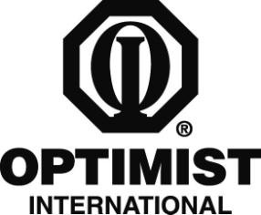

PRINT ON CLUB LETTERHEAD OR TYPE IN CLUB NAME

CONTACT
CLUB CONTACT CONTACT'S NUMBER

FOR IMMEDIATE RELEASE DATE

Local Student Wins Optimist Club Oratorical Contest

CITY, STATE/PROVINCE – STUDENT NAME, a YEAR IN SCHOOL at SCHOOL, recently won the Optimist Club of CLUB NAME’s oratorical contest based on a theme of “What the World Gains from Optimism.”

STUDENT'S LAST NAME was awarded AWARD for the honor. In addition, STUDENT'S LAST NAME will be sent to the zone level where HE/SHE will compete against winners from other Optimist Clubs in the area. The winner of the zone competition will be sent to the District level with the chance to win a scholarship, and then possibly on the Optimist International Regional /World Championship for a chance to win an additional $5,000 or up to another $15,000 scholarship.

“STUDENT NAME did a wonderful job presenting HIS/HER speech about the questions posed to HIM/HER,” Club President PRESIDENT NAME said. “The members of our Optimist Club have no doubt that STUDENT NAME has a bright future ahead of HIM/HER.”

The Optimist Club of CLUB NAME has been participating in the Optimist Oratorical Contest for

NUMBER years and has been active in the community since CHARTER YEAR. Other programs and service projects that the Club is involved in include CLUB PROJECTS.

Optimist International is one of the world’s largest service club organizations with 93,000 adult and youth members in 3,200 clubs in the United States, Canada, the Caribbean and Mexico and throughout the world. The Optimist Oratorical Contest is one of the organization’s most popular programs, with more than 2,000 clubs participating annually. Carrying the Mission Statement “By providing hope and positive vision, Optimists bring out the best in youth, our communities and ourselves,” Optimists conduct positive service projects that reach more than six million young people each year. To learn more about Optimist International, please call (314) 371-6000 or visit the organization’s website at www.optimist.org.

###

