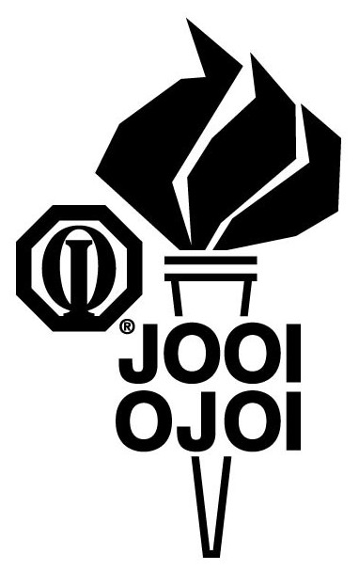

PRINT ON CLUB LETTERHEAD OR TYPE IN CLUB NAME

CONTACT
CLUB CONTACT
CONTACT'S NUMBER

FOR IMMEDIATE RELEASE
DATE

Local Youth Club to Promote Literacy During Reading Month

CITY, STATE/PROVINCE – Members of CLUB NAME hope to get fellow students reading good books during JOOI of Reading Month in MONTH OF EVENT at SCHOOL.

Students at SCHOOL have been challenged to read NUMBER OF BOOKS books during JOOI of Reading Month. With NUMBER OF STUDENTS students in the school, that comes to a grand total of TOTAL NUMBER OF BOOKS books for the month of MONTH.

“We want kids to discover how much fun reading can be,” said NAME, TITLE OF CLUB OFFICE of the JOOI Club. “Sometimes students get so focused on reading for classes that they forget to pick up good books during their free time. There are some really cool stories out there, and we want every student in our school to read a few this month.”

The JOOI Club is part of Junior Optimist Octagon International (JOOI), the youth clubs component of Optimist International, one of the world’s largest service club organizations. The JOOI organization recently began a program called the JOOI of Reading to help children discover the fun of reading and improve literacy rates at the same time.

CLUB NAME has been active at the school since CHARTER YEAR. Other programs and service projects that the JOOI Club is involved in include LIST CLUB PROJECTS.

JOOI has a membership of more than 15,000 students in almost 550 clubs throughout the United States, Canada, the Caribbean and other areas of the world. To learn more about JOOI, please call (314) 371-6000 or go to www.optimist.org and look under “Youth Clubs.”

###

