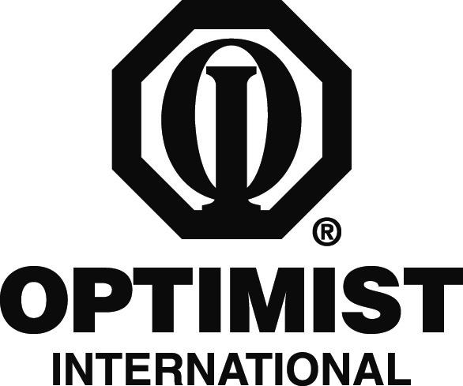

PRINT ON CLUB LETTERHEAD OR TYPE IN CLUB NAME

CONTACT
CLUB CONTACT
CONTACT'S NUMBER/E-MAIL

FOR IMMEDIATE RELEASE
DATE

Local Optimist Volunteers Wear Nametags for a Friendlier Society

CITY, STATE/PROVINCE – The Optimist Club of CLUB NAME is working toward a friendlier society this month thanks to a new program called “Hello, My Name Is ... .”

Throughout this month, local residents may notice members of the Optimist Club wearing red “Hello, My Name Is ...” nametags wherever they go. The effort is to draw attention to the Optimist Club’s efforts and encourage communication.

“Wearing a nametag gives someone unspoken permission to come up and say hello to you,” Club President PRESIDENT NAME said. “It gives perfect strangers the feeling that you are someone they can get to know. This October, it is our goal to say hello and introduce ourselves to as many people as possible and give them a chance to get to know us as individuals and as volunteers in the community.”

The local Optimist Club is just one of many clubs throughout the organization that will be holding “nametag rallies” this month. The international organization has also partnered with author and speaker Scott Ginsberg, known as “The Nametag Guy,” to reinforce the program’s goal – approachability.

The Optimist Club of CLUB NAME has been supporting local youth since CHARTER YEAR. Some of the programs and service projects that the Club is involved in include CLUB PROJECTS. The Club is currently working on UPCOMING CLUB PROJECT.

The Optimist Club meets MEETING TIME AND FREQUENCY at LOCATION. The Optimist volunteers welcome newcomers to their meetings. For more information about the Optimist Club, please call CONTACT NUMBER.

Optimist International is one of the world’s largest service club organizations with 75,000 adult and youth members in 2,600 clubs in the United States, Canada, the Caribbean and Mexico and throughout the world. Carrying the motto “Bringing Out the Best in Kids,” Optimists conduct positive service projects that reach more than six million young people each year. To learn more about Optimist International, please call (800) 500-8130 or visit the organization’s website at www.optimist.org.

###

