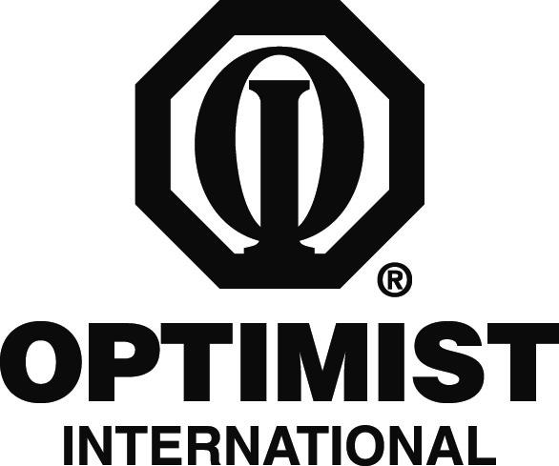

PRINT ON CLUB LETTERHEAD OR TYPE IN CLUB NAME

CONTACT
CLUB CONTACT
CONTACT'S NUMBER

FOR IMMEDIATE RELEASE
DATE

Local Club Pairs Up with NAME OF ENDORSED ORGANIZATION

CITY, STATE/PROVINCE – The Optimist Club of CLUB NAME is pairing up with ENDORSED ORGANIZATION to help local children.

ENDORSED ORGANIZATION is an organization that EXPLAIN WHAT ENDORSED ORGANIZATION DOES. The organization is also endorsed by Optimist International, which means that the International Board of Directors has examined the organization and has found it to be suitable for partnership with Optimist Clubs.

In its partnership with ENDORSED ORGANIZATION, the Optimist Club plans to EXPLAIN PROJECT.

“We are quite excited about establishing our new relationship with ENDORSED ORGANIZATION,” Club President PRESIDENT NAME said. “They have made a big difference to children in a number of communities and we can’t wait to get started in our work with them.”

The Optimist Club of CLUB NAME has been supporting local youth since CHARTER YEAR. Other programs and service projects that the Club is involved in include CLUB PROJECTS.

Optimist International is one of the world’s largest service club organizations with 75,000 adult and youth members in 2,600 clubs in the United States, Canada, the Caribbean and Mexico and throughout the world. Carrying the motto “Bringing Out the Best in Kids,” Optimists conduct positive service projects that reach more than six million young people each year. To learn more about Optimist International, please call (314) 371-6000 or visit the organization’s website at www.optimist.org.

###

