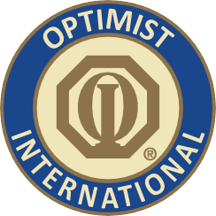

PRINT ON CLUB LETTERHEAD OR TYPE IN CLUB NAME

CONTACT

CLUB CONTACT CONTACT'S NUMBER

FOR IMMEDIATE RELEASE DATE

**Local Optimist Club Wins Big with Service Project**

CITY, STATE/PROVINCE – The Optimist Club of CLUB NAME has been honored by DISTRICT/OPTIMIST INTERNATIONAL with a Community Projects Award for its CLUB PROJECT NAME.

CLUB PROJECT NAME took LIST PLACE place in the CATEGORY TYPE category. The award-winning project involves EXPLAIN PROJECT.

The Community Projects Awards Program is an annual competition that recognizes Optimist Clubs for their community service, youth and fund-raising activities.

First-place winners of district competitions move on to compete at the international level each spring, and international-level winners are recognized at the organization’s international convention each July.

“The Optimist Club of CLUB NAME is very proud of the honor it has received from Optimist International,” Club President PRESIDENT NAME said. “But most importantly, our club is proud of the children we have been able to serve because of the project.”

The Optimist Club of CLUB NAME has been supporting the youth of COMMUNITY for NUMBER years. Other programs and service projects that the Club is involved in include CLUB PROJECTS.

Optimist International is one of the world’s largest service club organizations with over 80,000 adult and youth members in almost 3,000 clubs in the United States, Canada, the Caribbean and Mexico and throughout the world. Carrying the motto “Bringing Out the Best in Youth, in our Communities, and in Ourselves,” Optimists conduct positive service projects that reach more than six million young people each year. To learn more about Optimist International, please call (314) 371-6000 or visit [the organization’s website at www.optimist.org.](http://www.optimist.org/)

###