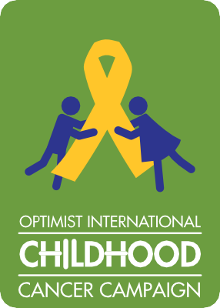

Childhood Cancer Campaign
Club and District Matching Grant Application

Optimist Clubs may use this application and attach additional pages as needed. Incomplete applications will be returned to the contact person listed on this application for completion and will not be reviewed. Applications should be submitted after Club/District has approved project. Clubs may submit one CCC matching grant request per Optimist year.
These funds are intended to be used for Optimist Club projects and not to fund other Foundations and/or organization’s programs. Projects can only be submitted for grant consideration once, regardless of whether they are ongoing projects.

Club/District Name: Number:

Contact Person: Last Name:

Mailing Address:

City: State/Province:

ZIP/Postal Code: Country:

Phone: E-mail:

Please provide a brief description of the project below & anticipated cost of project:

Is project annual or ongoing? Date of Current Project
If annual, how many years has it been run? Grant Amount Requested: $

How much Club/District money has been raised for the current project?
(Please do not list amount raised for project during total number of years it has been conducted).
What is the goal of the project?

Why did your Club choose to allocate the funds in this way?

How will this goal be achieved?

How would this grant allow the project to achieve something not possible in the past?

How will the project impact children with cancer, their families and/or their caregivers?

How will this project impact the Childhood Cancer Campaign?

How did you hear about the CCC Matching grant program?

In order for this application to be complete the following documents must be attached:
- A Project budget detailing project expenses and anticipated income sources.
- A list of the members of your Board of Directors or District Officers including names & titles.
It is the decision of the Advisory Panel to grant either the full or a portion of the amount requested. Only the amount requested or a portion of that amount will be granted. 50% of the amount granted will be paid upon approval with 50% being paid after all paperwork and final report have been received by Optimist International. Grant checks will be sent to the Club or District Treasurer. The minimum amount grant requested is $250.00 with a maximum grant being $1,000.00. Projects designed to fund other Foundations and/or organizations will not be considered. ALL decisions of the Advisory Panel are final.
Send completed application to: Optimist International, c/o CCC
4494 Lindell Blvd., St. Louis, MO 63108 Fax: (314) 371-6006 • ccc@optimist.org

ADVISORY PANEL APPROVAL
Date report received: Conditions of approval (procedures to follow or specific instructions):
PROJECT NAME:
PROJECT NUMBER:

